NAME :B.THARUN KUMAR REDDY

REG.NO : 192111508

COURSE :COMPUTER NETWORKS

CODE :CSA0719

FACUTY :DR G ANITHA

LAB 6 TO 10

6.Static Routing using Packet Tracer

**STATIC**

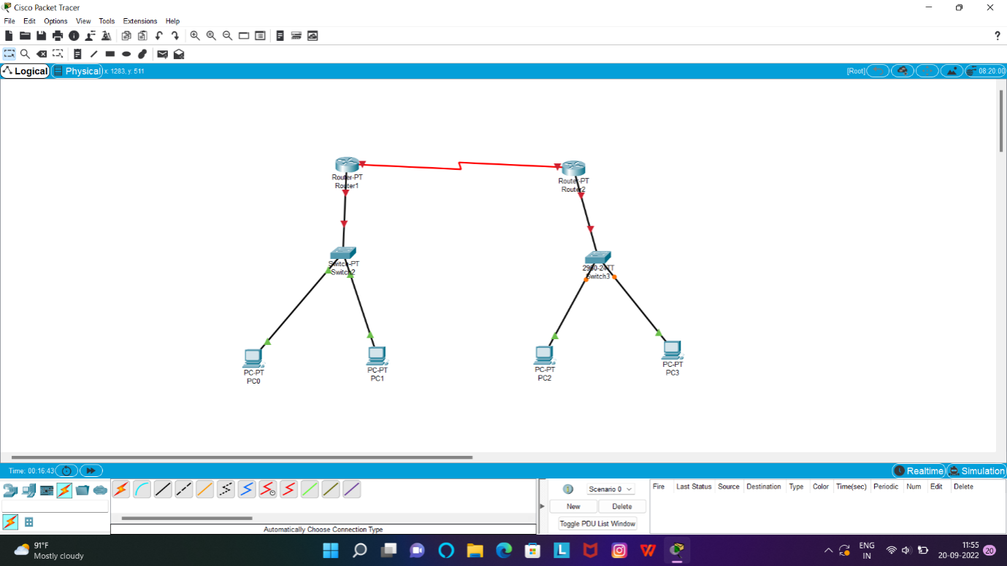

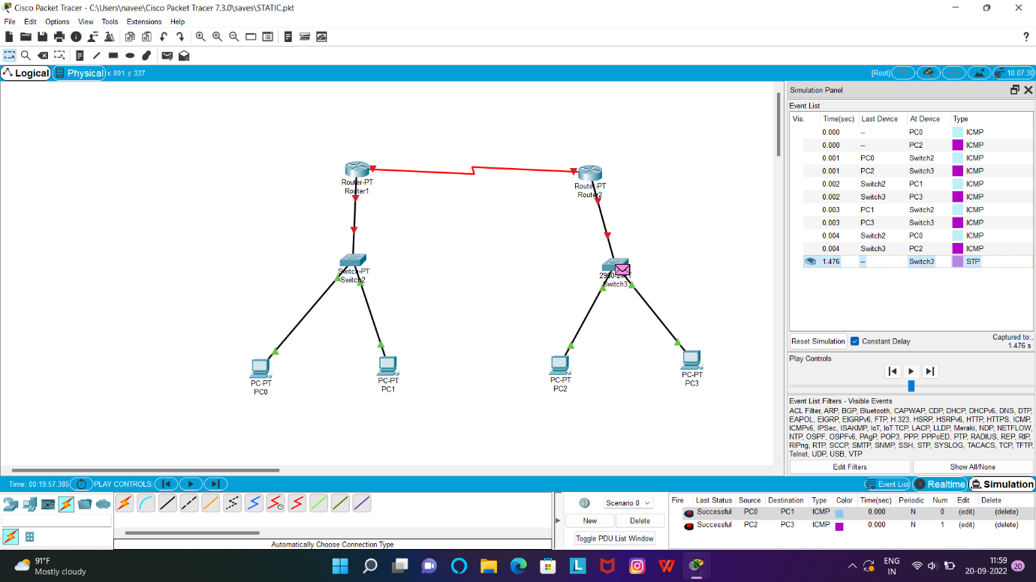

7.Dynamic Routing using Packet Tracer ( OSPF)

**DYNAMIC:**

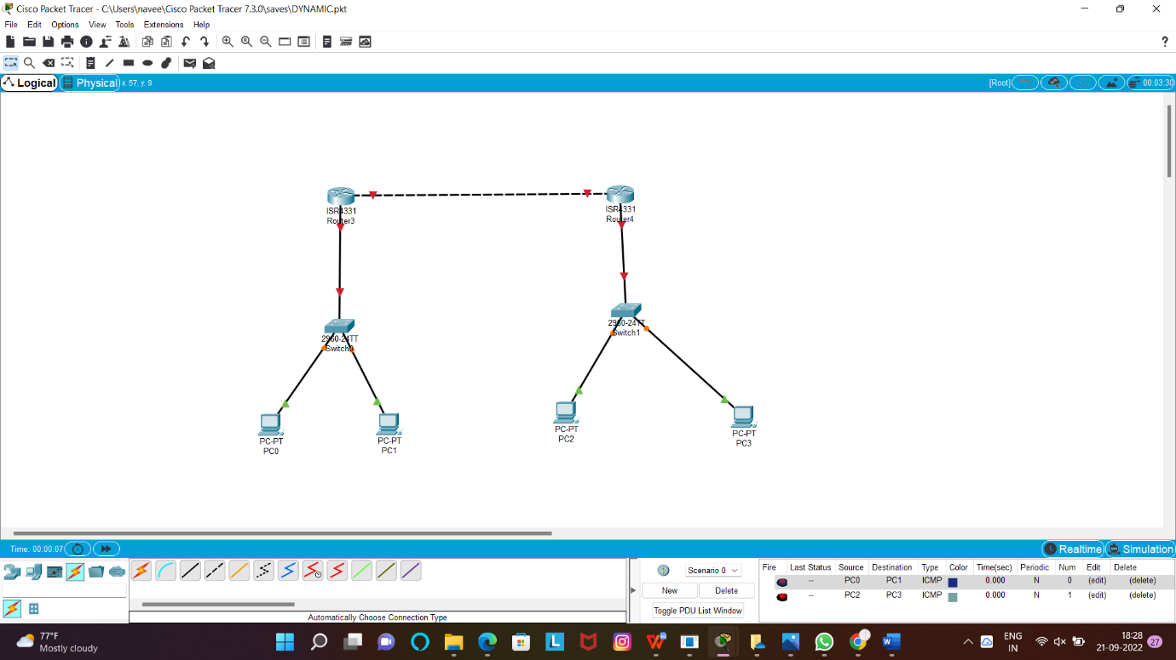

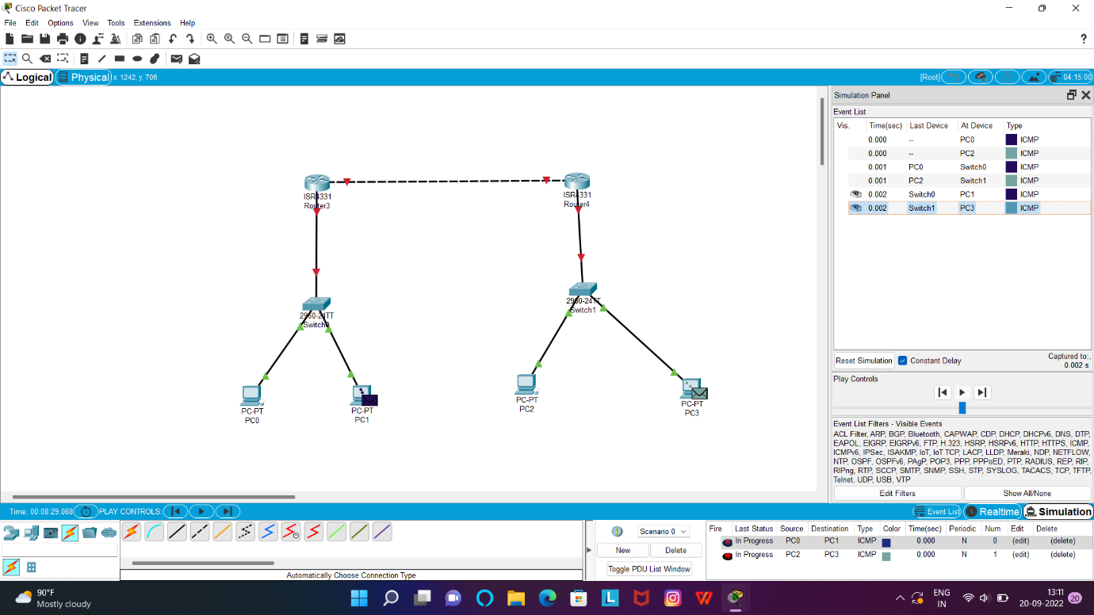

8.Subnetting – Class C Addressing

**SUB NET CLASS C:**

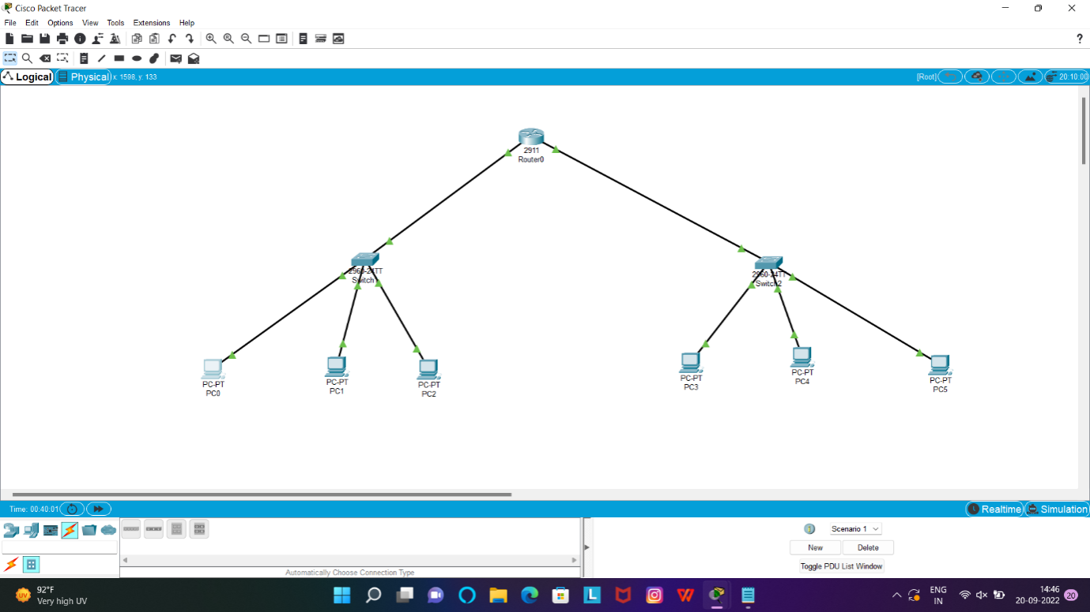

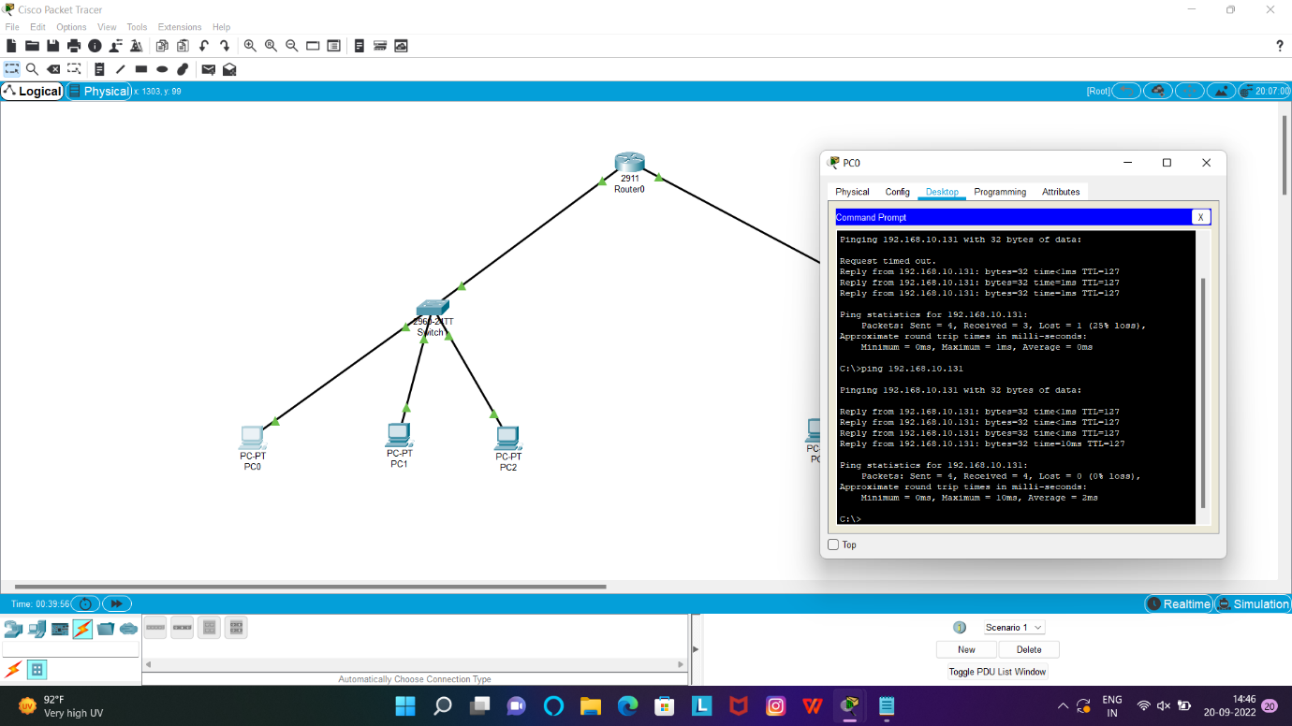

9.Functionalities of TCP, UDP

**TCP,UDP**

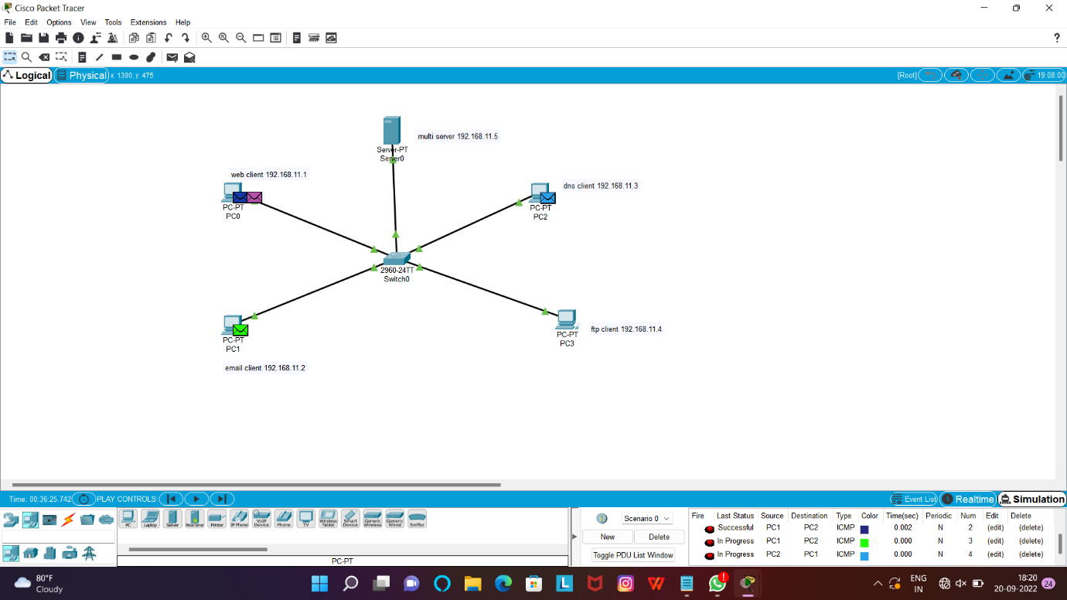

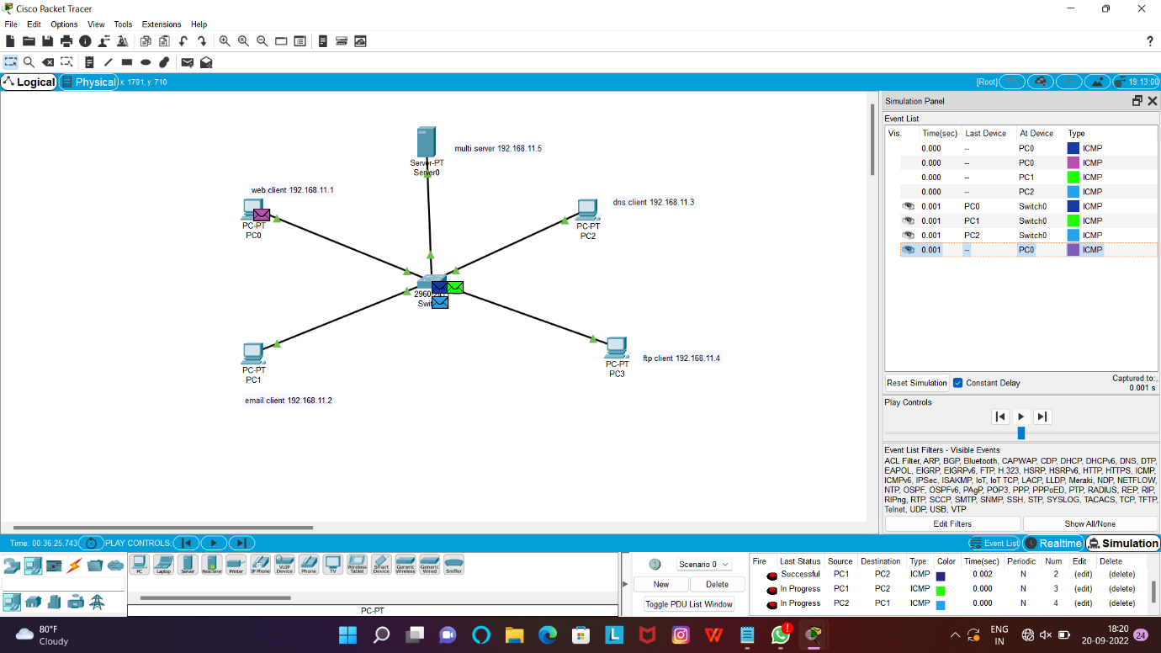

10.TCP, UDP Exploration Solution

**TCP,UDP**

